TITLE PAGE
TECHNICAL REPORT ON STUENTS INDUSTRIAL WORK EXPERIENCE SCHEME (SIWES)

AT
MECHANICAL ENGINEERING DEPARTMENT, GOVERNMENT TECHNICAL COLLEGE, ABAKPA, OGOJA, CROSS RIVER STATE

FROM: 6TH OCTOBER, 2023
TO: 29TH JANUARY, 2024

BY
IJOKO, SOLOMON AJAP
(ET/ME/ND/22/054)

THIS TECHNICAL REPORT IS SUBMITTED IN PARTIAL FULFILMENT OF THE REQUIREMENTS FOR THE AWARD OF NATIONAL DIPLOMA (ND) IN MECHINICAL ENGINNERING TECHNOLOGY, FEDERAL POLYTECHNIC MUBI.

JUNE, 2024.

CERTIFICATION
This report written by Idoko Solomon Ajap with registration number ET/ME/ND/22/054 was certified and approved by the following

SIWES Supervisor _____________ _____________
Mr. I. I. Sambo Sign Date

SIWES Coordinator _____________ _____________
Dr. Mohammed Bashiru Sign Date

Head of Department _____________ _____________
Engr. Agbana Cosmos Sign Date

DEDICATION
This work is dedicated to my beloved parents for leading me into intellectual pursuit by giving me the financial support, in addition to the enormous contribution (financially and morally) made by my brothers and family members.

ACKNOWLEDMENT
All glory be to God almighty the creator of heaven and earth for his sufficient grace throughout the period of my SIWES program and I thank God for giving this great opportunity.
I also thank my family, friends and relative for supporting me morally and financially throughout my education and successful completion of my student industrial work experience scheme (SIWES) program.
I would also like to express my infinite thanks to the entire management and staff of Government Technical College for honoring me and accepting my application and helpful relation accorded to me during the period of my attachment.
I also thank Engr Ojong Ojong Eyam, my industrial supervisor for his dedication, concern and contribution during the period of my SIWES program. Finally, I will like to show my appreciation to my HOD Engr. Agbana Cosmos, My SIWES Supervisor and all staff of Mechanical Engineering Federal Polytechnic Mubi, Adamawa state of Nigerian

SUMMARY
This technical report comprises of four (4) chapters. Chapter one comprises of Introduction to SIWES, History of SIWES, Aim and Objectives of SIWES, chapter two comprises of Overhauling of a SUMEC fireman generating set, Chapter three comprises of Welding operation, Lathe machine, Milling operation, Boring on lathe machine, Injector and Nozzle Servicing, Chapter four comprises of the Conclusion and the Recommendation on the SIWES.

TABLE OF CONTENT

TITLE PAGE i
CERTIFICATION ii
DEDICATION iii
ACKNOWLEDMENT iv
SUMMARY v
TABLE OF CONTENT vi
CHAPTER ONE 1
1.1 Brief history of organization 1
1.2 Aims and Objectives of SIWES 1
1.3 Orientation exercise given to student on arrival 2
CHAPTER TWO 4
2.0 MAINTENANCE OF WORKSHOP MACHINES CARRIED OUT 4
2.1 Measurements and marking out 4
2.2 Marking Out Tools 5
2.3 Cutting and work holding tools: 7
CHAPTER THREE 9
3.0 Welding Operation 9
3.1 Type of work carried out using oxy-acetylene 9
3.2 Procedure followed to cut a metal plate 9
3.3 Electric arc welding 10
3.4 Setting up for arc welding 10
3.5 Drilling on the machine 10
3.6 Drilling of a 40mm diameter round work piece 10
CHAPTER FOUR 11
CONCLUSION AND RECOMMENDATION 11
4.1 Conclusion 11
4.2 Recommendation 11
REFERENCES 12

CHAPTER ONE

1.1 Brief history of organization
The mechanical engineering department of government technical college Abakpa, Ogoja. Cross river state is a department established or built after the school was created to enhance learning to students who wish to study mechanical engineering in the higher level of education, to get a build up knowledge from the secondary level of education before advancing to a higher level so as not to have difficulties at the higher level
The department is well equipped with mechanical engineering machines tools, equipment to enhance a better learning and attain better learning or understanding.
Student who carried out their SIWES in the department had gain much knowledge during the exercise.

1.2 Aims and Objectives of SIWES
The student’s industrial work experience scheme (SIWES) is a program in cooperated into the academic curriculum of most institution of higher learning.
This program was introduced by the federal government since 1974 for students in tertiary institution.
The student industrial work experience scheme is a program sponsored and monitored by industrial training fund (ITF) especially designed for science technology and engineering students to have a practical knowledge on what have been taught in the class rooms. Therefore, the program enables students to have more knowledge and experience when working in the field or office.
The industrial training fund was established by degree N47 of 8th October, in promoting and encouraging the acquisition of skills in the industrial with a view of generating not of ingenious trained man-power sufficient to meet the economy bony of the aim and objective include.
- To enable students to acquire necessary experience in their field of study.
- To expose the students to various production equipment’s and machines that are not available in their institution.
- To expose students to several tedious and complex machines operation, maintenance and production.
- To enable students to develop students in terms of personal relation.

1.3 Orientation exercise given to student on arrival
The student industrial work experience scheme (SIWES) was carried out for a period of four (4) months from the 6th of October, 2023 to 29th January, 2024
On arrival to the place of my industrial attachment (IT) I submitted the necessary documents to the industrial secretary and a file was opened for me. I was later introduced by my supervisor to the staffs, and I was taken to the department and showed around.
The industrial based supervisor then gave me some piece of advice to enable me achieve my aim and objective at the end of the training.

1.4 Organizational Chart of Government Technical College, Ogoja
PRINCIPAL
VICE PRINCIPAL ADMINISTRATION
VICE PRINCIPAL ACADEMIC
STAFFS
STUDENTS
HEAD OF DEPT.
STUDENTS
SIWES STUDENT

Figure 1.1: Organizational Chart

CHAPTER TWO

2.0 MAINTENANCE OF WORKSHOP MACHINES CARRIED OUT
Every day in the work shop, I took part in the maintenance and cleaning of the work shop and machine to be functioning successfully at all times.
During the cleaning of the work shop, I used materials like broom, wire brush and parker to remove particles like sand and chips on the work shop floors.
In cleaning of the machines, I used materials such as wire brush, brush and diesel to clean engine parts and oil split and free the movable parts of the machine. OUT

2.1 Measurements and marking out
Measuring tools are very important tool in engineering. I always carried out measurement when jobs were given to me to fabricate in the workshop.
The measuring tools I used were:
- The Vernier Caliper
- The micrometer depth gauge
- The engineering steel tape
- The engineering steel rule
- Vernier Caliper: I used the Vernier caliper to measure and gauge the external and internal diameter of bars and tubes and shafts to get an accurate dimension in fig2c.
  - I took reading of the Vernier caliper which number of millimeter on the main scale to the left of zero of the Vernier scale are added. The number of 0.02mm on the Vernier scale coincide with a line on the main scale.
- The Micrometer Depth Gauge: I used the micrometer depth gauge to measure depth of holes and slots.
- The Engineering Tape: I used the engineering tape to measure the length of a rod, shaft that are long length.
- The Engineering Steel Rule: I used the engineering steel rule which is graduated in centimeters and inches to measure the length of a short work piece.
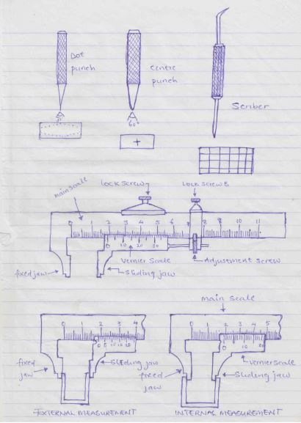
Figure 2.1: Vernier Caliper

2.2 Marking Out Tools
Marking out tools are simple equipment I used in the work shop for tiny indentation, scratch, cribbing marking, locating the dividing on a work piece before operation. These tools are:
- Centre punch
- The scriber
- The pair of dividers
- The try square
- The dot Punch

Figure 2.2: Marking out tools
- The center punch: The center punch is marking out tool, I used it to mark, or locate a center before drilling, either on a circle etc. this is to create a point on the work piece of that the drill bit would not wobble when introduced to the work. As shown in fig.2a.
- The scriber: The scriber is an engineering marking out tool simply called an engineering pencil, I used it to draw lines or scribe out a required like on the metal work piece. As shown in fig. 2b.
- The pair of divider: I used the pair of divider for marking out circle arcs, and radii, and for transferring measurements from engineering rate to work piece.
- THE TRY SQUARE: I used the try square in setting out lines at right and testing surfaces at 90ºeach other before carried out.

2.3 Cutting and work holding tools:
Cutting tools are available tools necessary in the workshop for their application for the cutting, chipping, sawing. drilling etc. they are made both of manual and electric machine in various size and with adaptors to such different application.
- The hack saw: I used the hacksaw for cutting off length of material to required dimension and sometimes used it to trim off.
- Files: I used a file when a fair amount of metal requires removal and I used the file to carry out finishing when working to fine limits i.e. for a good and smooth finish as shown in fig.3b. before. I carried out filling on a work piece, I make sure that the work was firmly clamped or held on a vice and the working surface as near as possible to the vice jaw, to prevent the work from vibrating and pull out.
- Chisels: I used chisels to cut cold metals or other designed parts on a work piece and plates
- The cross-cut chisel: I used the cross cut chisel to cut grooves such as slot, channels and keyways shown in fig,2c.
- The flat chisel: I used the flat chisel to cut sheet and plate metals and removing surplus metal from surface.
- Holding tool: I used holding tool to hold together pieces of work while marking out, filling, cutting, drilling and removing nuts from the bolts such holding tools are engineer’s vice, hand drill machine vice, hand vice and pliers.
- How I used the holding tools.
- The engineer’s vice is normally fitted on a stand which I clamped my work to mark out, tap and die, filling, drilling, punch and applied by tightening and loosening the end screw while I used the machine vice for holding work while being drilled with the electric drilling machine I used the hand vice and plier for holding small parts which cannot be held in an engineer’s vice or very hot and I ensured that I applied a suitable size holding tools for correct hob. And the work must be firmly held properly.
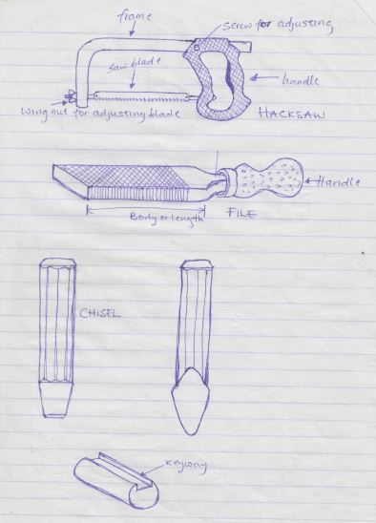
Figure 2.3: Hack Saw

Figure 2.4: Hand File



Figure 2.5: Chisel

CHAPTER THREE

3.0 Welding Operation
This is the process I used to cut or join two or more metals together with the application of gas and electric arc welding

3.1 Type of work carried out using oxy-acetylene
Oxy-acetylene can be used in welding various types of materials such as wire mesh in which it requires the application of brass and rod which serves as filler rod and gives the welding region strong binding forces. The brass rod should be dipped into flux to enable the brass rod easier to melt and flow to give a smooth surface finish. Other types of welding operation carried out using oxy-acetylene includes welding of components etc.
Metal-plate cutting operation was also accomplished using high temperature and a high pressure oxygen was introduced to blow out the molten metal and create the separation.

3.2 Procedure followed to cut a metal plate
- I marked the cutting line on the surface
- I set up the plate on the working table and allowed the place to be cut to hang over the table
- I lighted the flame with a spark lighter and adjusted for neutral pre heating flame.
- I positioned the pre-heat flame so that it matches with cutting line.
- When the metal is hot enough I slowly press the cutting lever.
- As cutting began fully I depressed the cutting and direct the low pipe along the cutting line with the nozzles at right so that it gives a good cutting.

3.3 Electric arc welding
Electric arc welding is a permanent joining method of two or more metals. I used the electric arc welding to join various metals together. Below are the steps on how I set up for electric arc welding.

3.4 Setting up for arc welding
- Firstly, I made sure that the welding machine was kept in a safe and comfortable place.
- I stretch out the twisted welding cables to the area I want to carry out the welding
- I checked the electrode holder whether the welding cable was properly fitted and tightened to the holder
- I checked whether the welding machine was properly connected to the electricity.
- I arranged the materials to be welded and kept them in a comfortable place
- I now kept the earth cable on the metal and started welding.

3.5 Drilling on the machine
Drilling on the machine is the machining process used to originate a hole to a required diameter using the machine.

3.6 Drilling of a 40mm diameter round work piece
- The 40mm diameter work piece was held firmly on a three-jaw chuck lathe machine
- An 18mm drill was selected and fixed correctly into the tail shock
- The lathe machine was ON, the headstock rotated with the work piece
- Then the drill was fed unto the center of the point to be drilled
- The drill was fed gradually unto the work piece as the tail stock spindle was turned to move in the drilling direction.
- Drilling of a blind and through hole was done the drilling process.

CHAPTER FOUR

CONCLUSION AND RECOMMENDATION

4.1 Conclusion
SIWES is an important process of equating the future. It exposes the student to practical of their class lectures, in other to bridge the gab.it also provides accurate and comprehensive assessment of the award of national diploma (N.D)
Through this training, one will realize the big difference between academic exercise practical and real-life experience. The exercise has enable me the opportunity to see, feel and practice In the area of my discipline.

4.2 Recommendation
Students do suffer during their attachment therefore; the allowance should be given to them by the establishment where the students is doing the industrial training (IT) and also by the industrial training fund (ITF) should be paid immediately they are through with the industrial training (IT).
They should also try their best to have connections with some companies so that during the period of SIWES their students can be divided to attach with them.

REFERENCES
Green, J. N. (1964). Introduction to Technical Drawing: Metal work theory for school certificate and GCE, McGraw Hill, New York.
Chapman, W. (1972). Work shop technology. Published by Hodder Headline Group

